Execution of commands for Git and Github task.

Step 1: Need to check Git version.
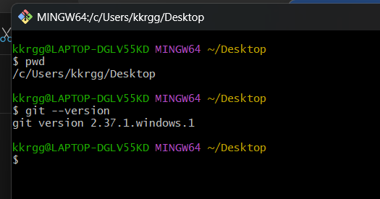

Step 2: Created Directory name : Hiring-app and also created file Dockerfile.txt in local.
Now check
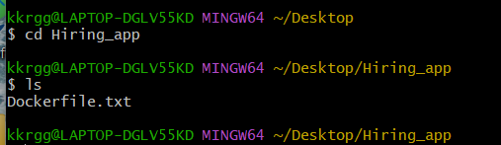

Step 3: check the changes
Command : git status
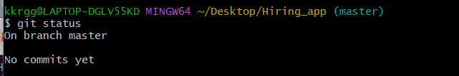

Step 4: track directory
Command : git init
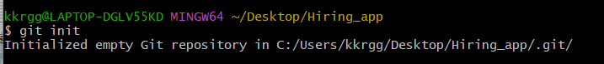
Check hidden file
Command : ls -a
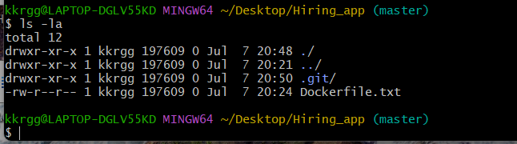
See configuration
Cd .git/
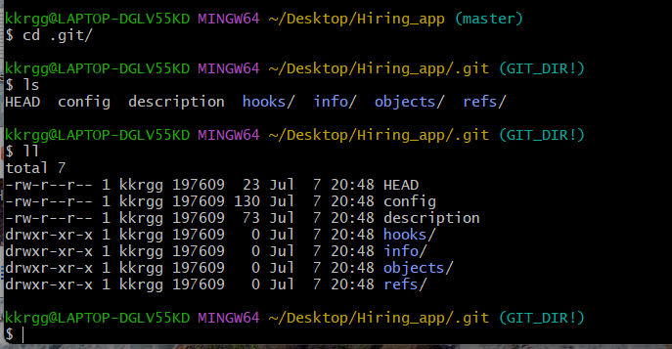
Check git status
Command : git status
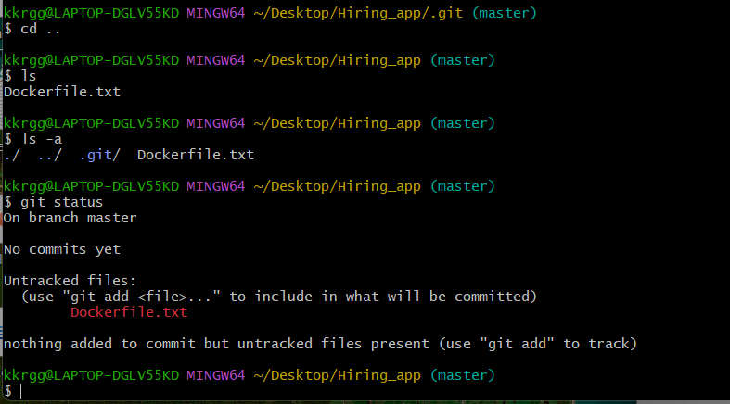

Step 5. Create sample file nikhil
Command : touch nikhil
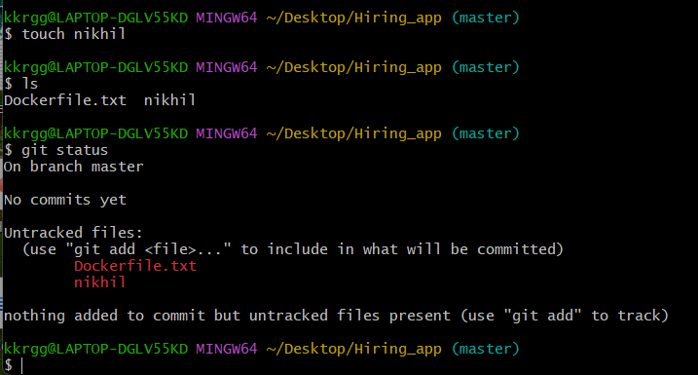
Command : git init 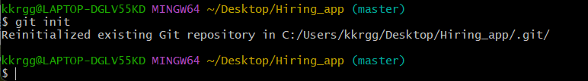

Check status
Command : git status
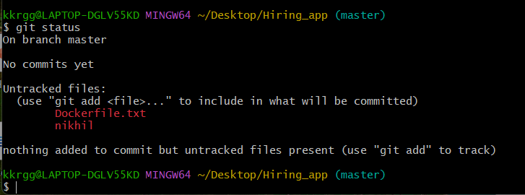

Step 6. Now we need to check configure username and email
Command : git config --list
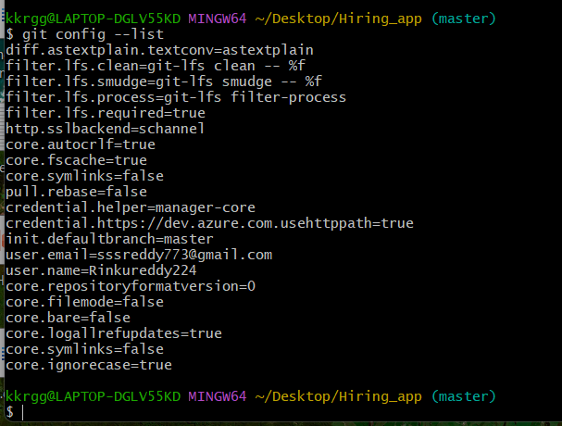
If we don’t have configuration of username and email need to configure
Note : without cofiguring username and email we can’t push file from local machine to central repo
Name configuration
Command : git config --global user.name “name”
Email configuration
Command : git config --global user.name “email”

Command : git config --list
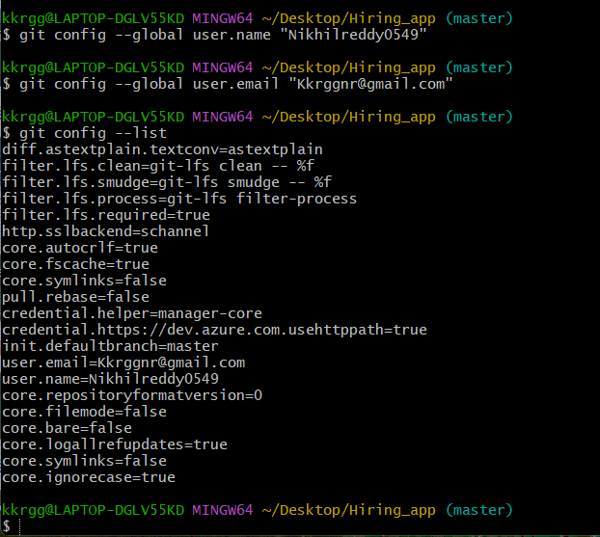

Step 7. Push from local system to contral repository
- need to move file from untracking to tracking area
Command : git add
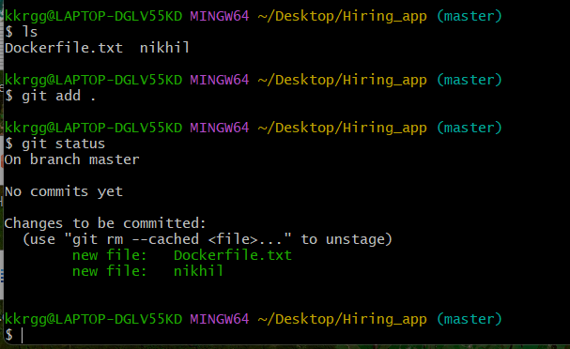

Step 8. How to push all file at once into git
- create sample files txt xml html jpeg
Command : touch txt xml html jpeg
Command : ls
- Check status of untrack files
Command : git status
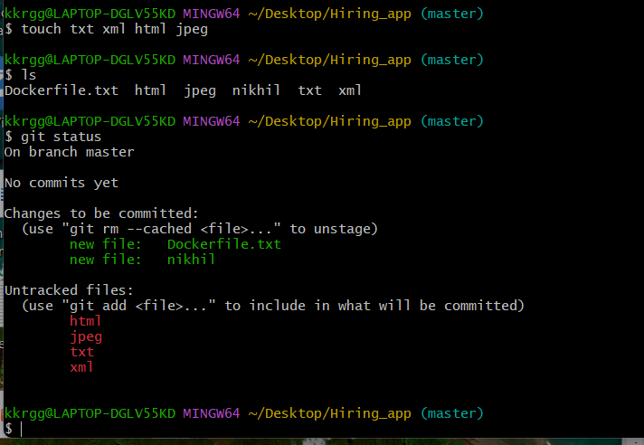
- Track all files txt xml html jpeg
Command : git add .(. dot means all file )
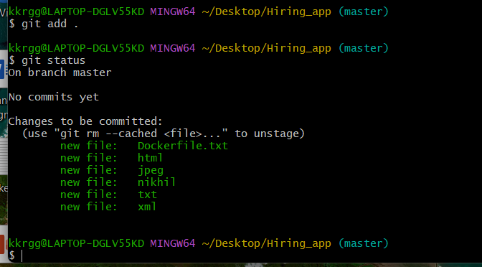

- Commit changes : it will store copy in the machine or it will track changes.
Command : git commit -m
-m message or comment
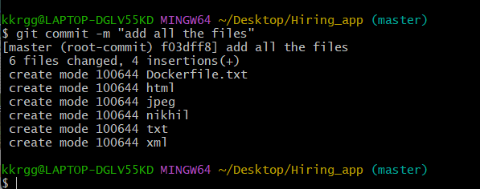
No commit pending
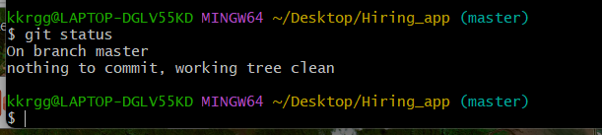
- To check commit number or id
Command : git log
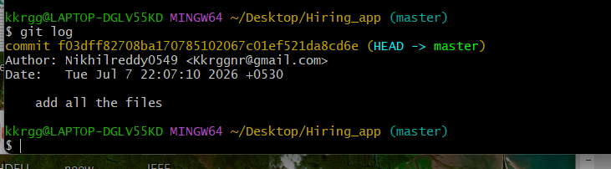

Step 9. Now we want to store all files in central repository (github)
- Go to github and create repository 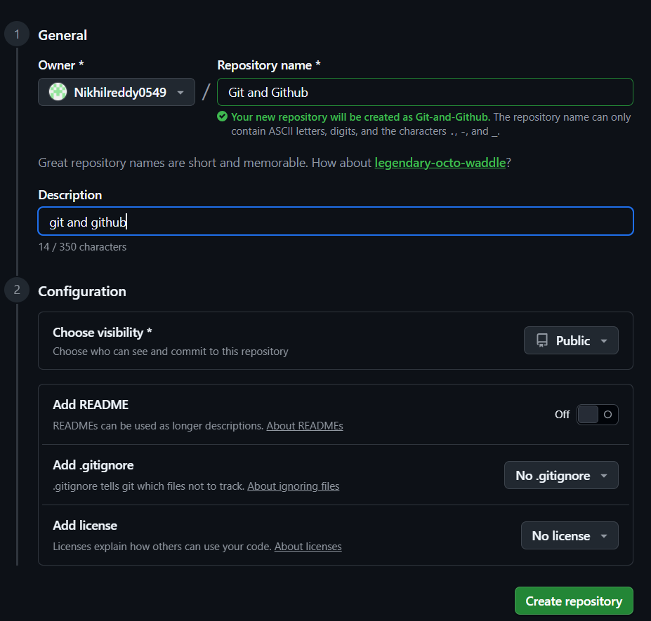
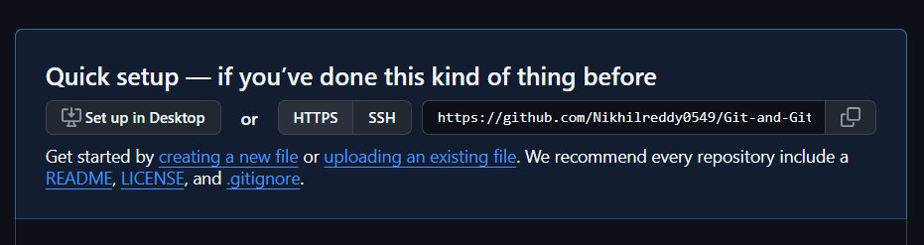
- In terminal -check if any address configure or not
Command : git remote -v
- Add SSH url (copy from gitbut and paste)
Command : git remote add origin git@github.com:Nikhilreddy0549/Git-and-Github.git
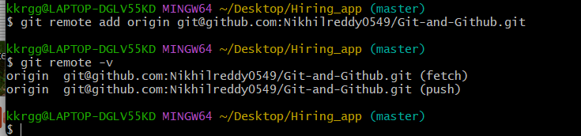

Step 10. Before push we need have connectivity from ssh
- Generate SSH key Command : ssh-keygen
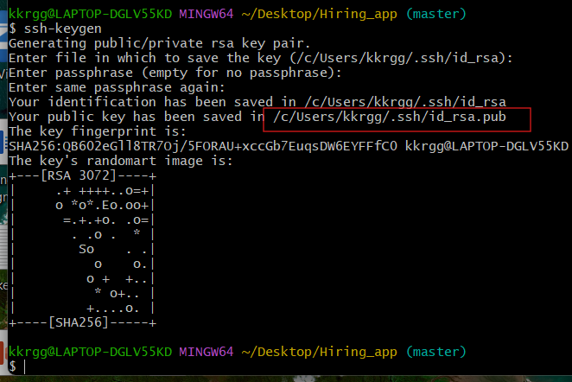

- Read ssh key
Copy public key and go to github
command : cat /c/Users/kkrgg/.ssh/id_rsa.pub
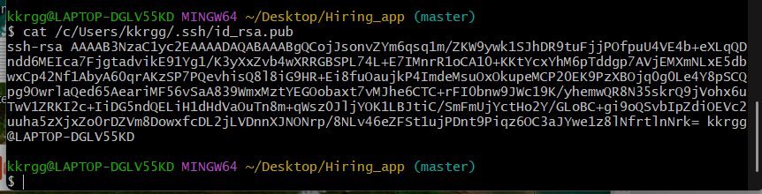
Got to github profile --- setting -- ssh and gpg keys
Copy ssh key terminal and paste in github
Click on add SSH key
- Now we can push
Command : git push -u origin main
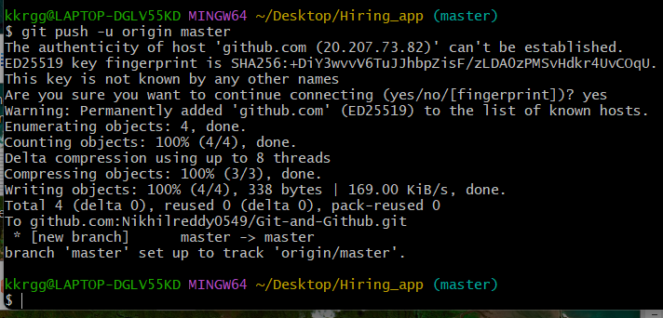

- Got to github and refresh page
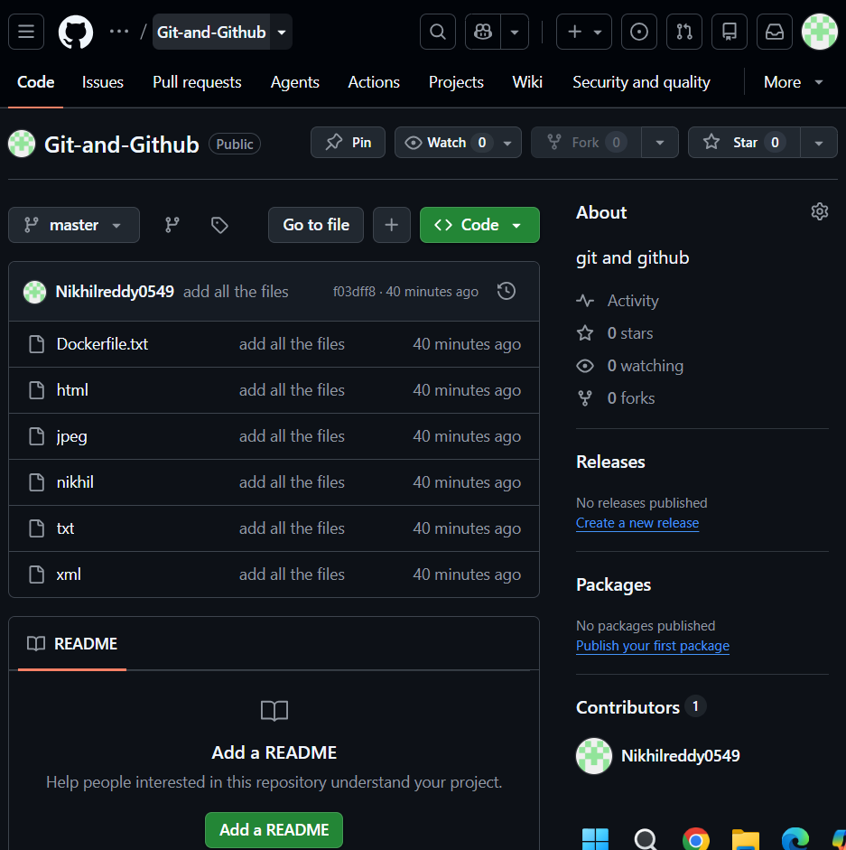

Scenario 1: If a file is deleted from the local system, it will not be deleted from the central repository until the changes are committed and pushed.

- The file is deleted only from your local working directory.
- The file still exists on GitHub because you haven't informed Git about the change.

Step 1: delete file from locate system
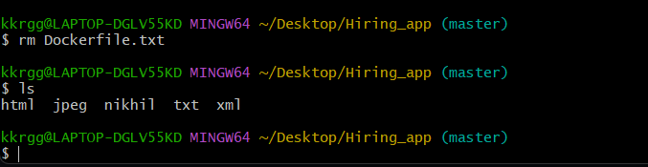
This file deleted from local
Step 2: To delete from github or to sync local and central
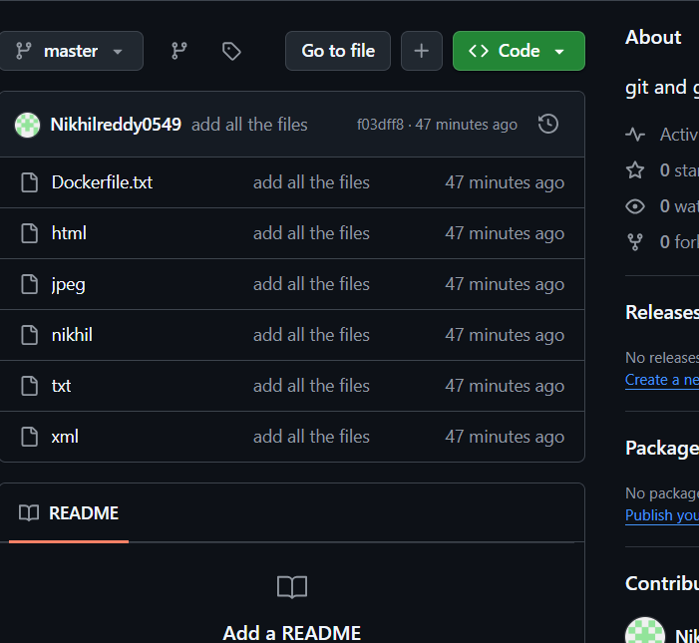
Step 3: check status Command : git status
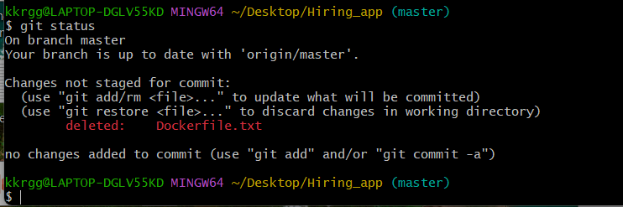
Step 4: update the changes
Command : git add .
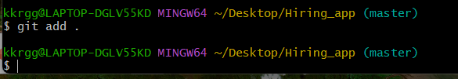
Step 5: commit the changes
Command : git commit -m “deleted dockerfile”
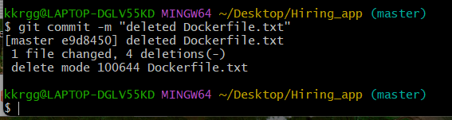
Step 6: push all changes to central repository
Command : git push -u origin main
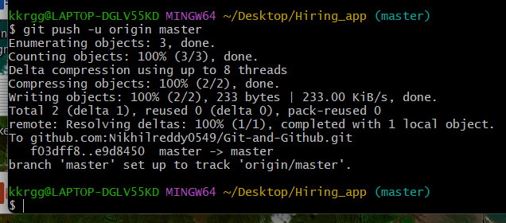
Step 7. Goto github and refresh 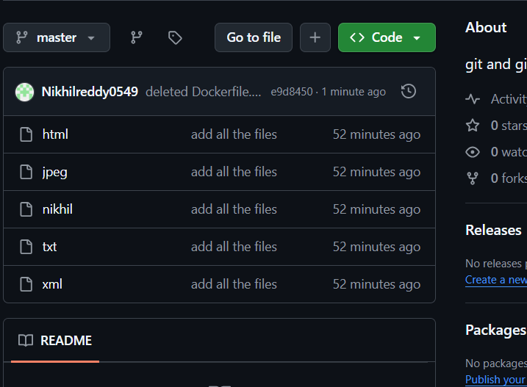 Dockerfile.txt is deleted

Scenario 2: If a file is created in GitHub, it will not appear in the local system until you pull the latest changes.

Step 1: create file reddy in github
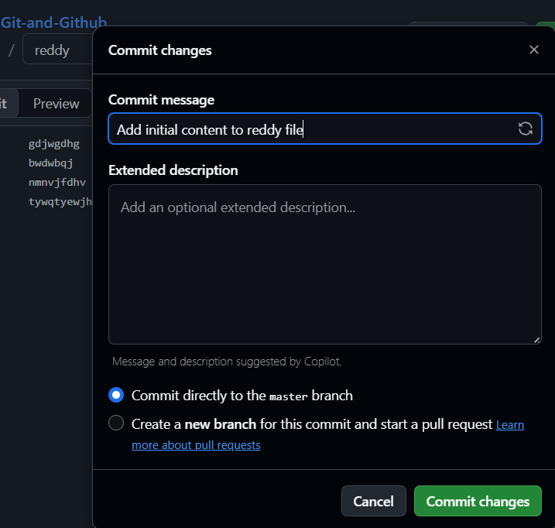
Step 2: create file in local system
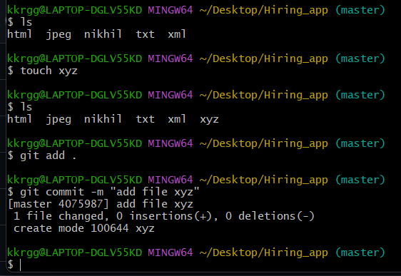
Now if want to push the files it will through error because local and central repositories are not sync
command : git push -u origin main
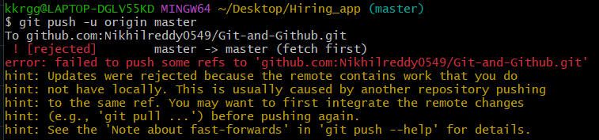
Step 3: central to local we need pull file
Command : git pull
Now we can see reddy file in local machine 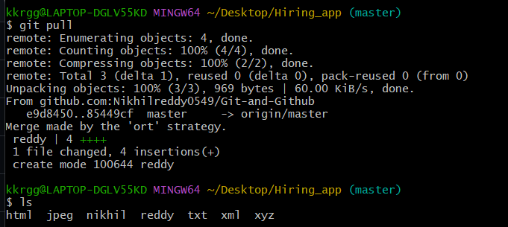
Step 4 : now push changes will be push to local to central
Command : git push -u origin main
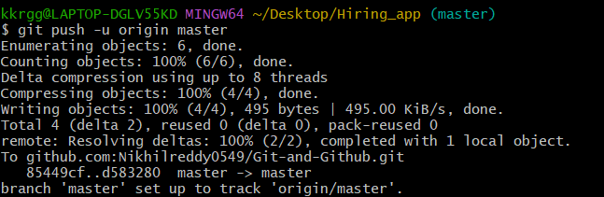

Local file xyz added and central repo file able to see in local.
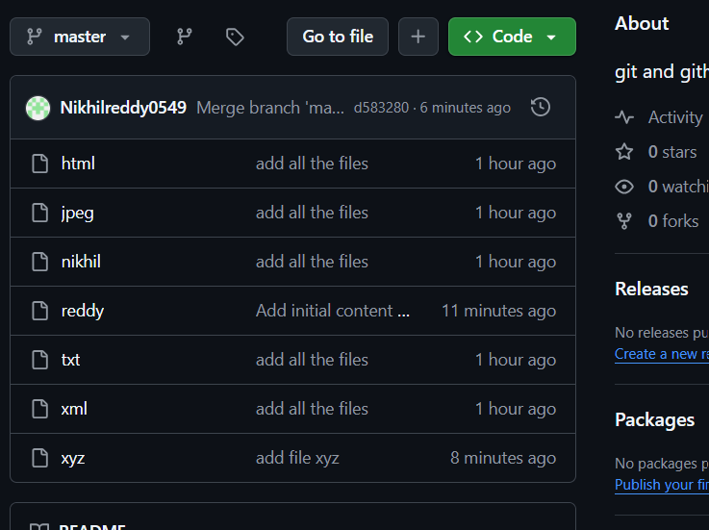
Git clone
Help us to download the source code form central to local
Command : git clone git@github.com:Nikhilreddy0549/Git-and-Github.git
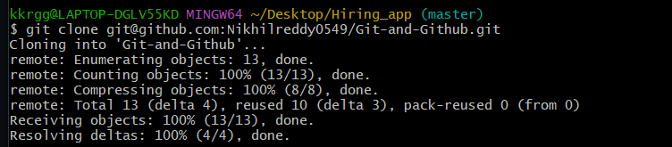
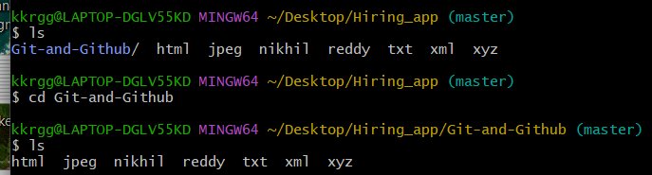

Senario : Directory deleted from local system how to download from central repo
Command : git clone

Senario : how to retrieve deleted file
Command : git revert <commit id>
To know commit id we need run git log
Command : git log -4
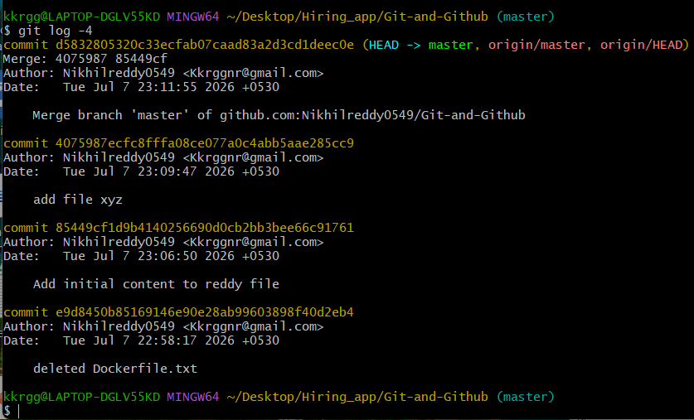
After that need to revert back
Command : git revert <commit id>
Dockerfile.txt has been revert
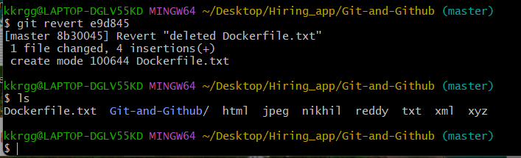

How to change tracked file to untracked file
Create a file name as samplefile
Command : touch samplefile
Command : git add .
Then execute command “git status” it will show the file in untracked list. So execute the command “git add .”
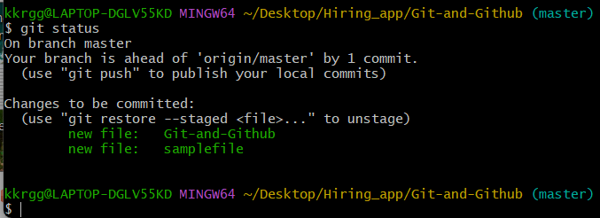

How to move file to untracked area.
Command : git reset
